BMGT1002: Test plan
Test period: *March to April*
Test Browser: Chrome
Test Device: Laptop
Test No. | Test Type | Test Case and location | Test input and criteria | Expected Result | Test Result  (Actual) | Status (Pass/Fail) | Actions needed (if applicable) or Comments | Screenshots
1 | Unit | Testing: we looked at the hello interaction.  Location: It is the very first interaction of chatbot.  Google chrome on my laptop. | Input – click on test interaction.  Criteria: the button will allocate you to different categories when you click on ‘test interaction’. | A variety of 3 buttons will show up and from there you can go any direction. | The result that happened is the exact I expected. | pass | No actions were needed to act. | 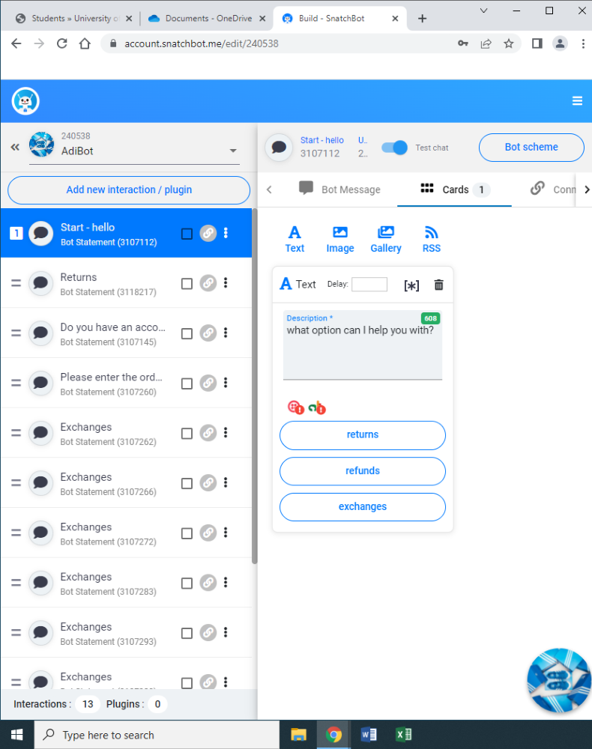
2 | Unit | Testing: Returns, exchanges and refunds connection  Location: first real interaction of chatbot.  Using snatchbot on google. | Input: press on test interaction  Criteria: button allocates you to different category is shown when you test the interaction. | A button which allocates to different categories should appear with ‘returns, exchanges and refunds. | The result that happened is what I expected. | Pass | No actions were needed to act. | 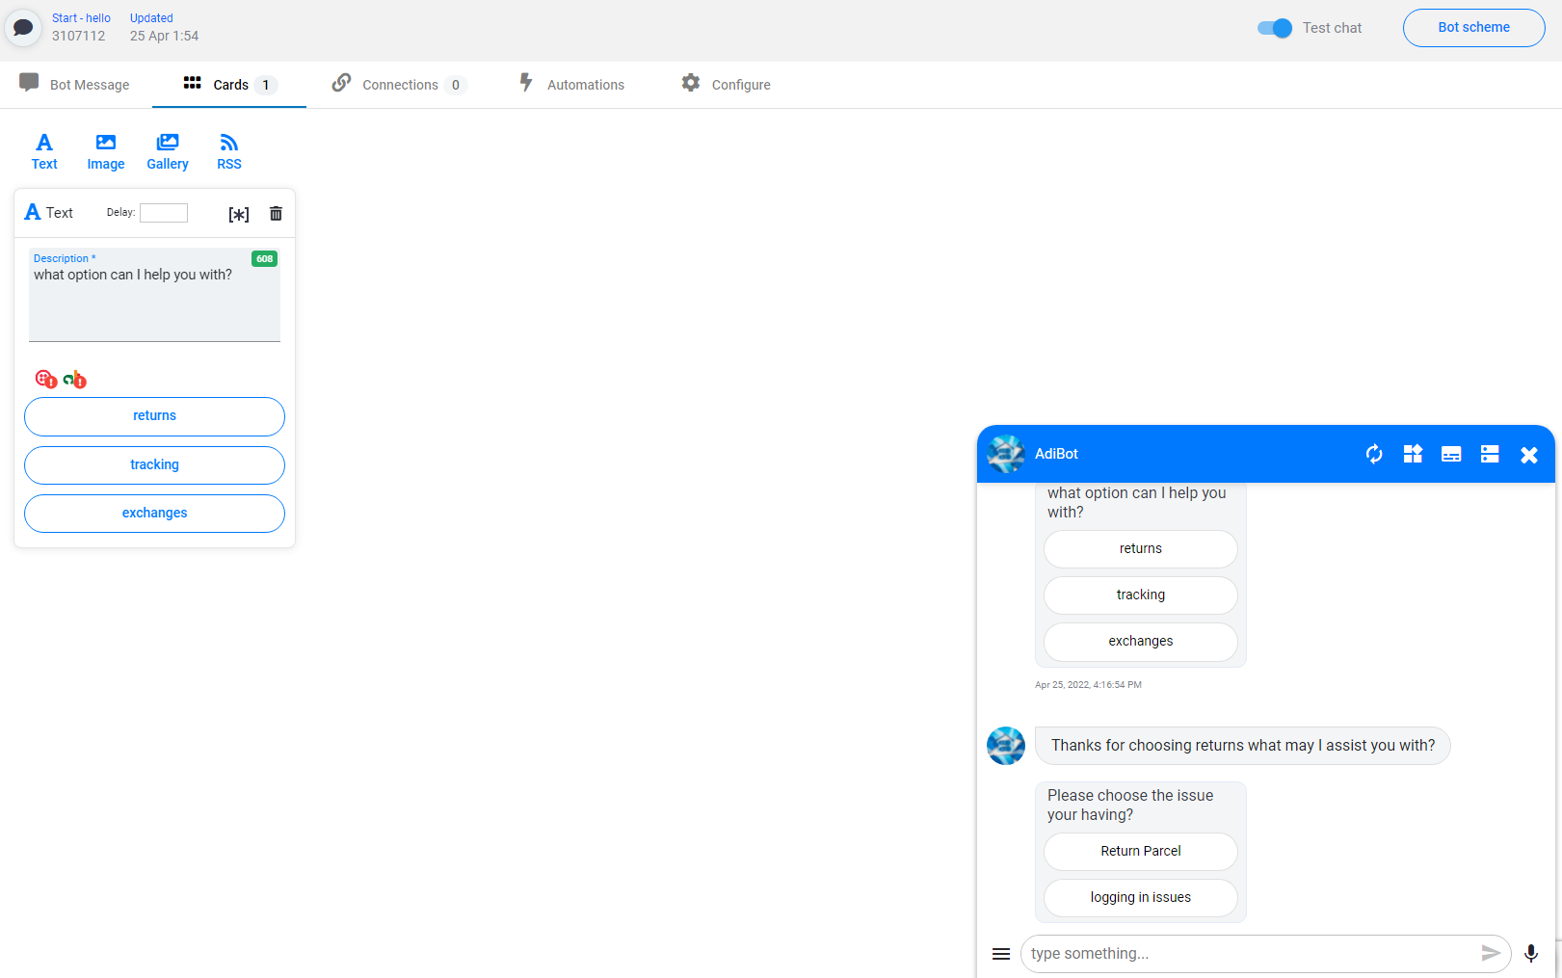
3 | Unit | Testing: returns and looking and further interactions.  Location; 2nd interaction of the return part of the snatchbot. | Input: press on test interaction criteria.  You will have 2 interactions 2 go from. | You will have 2 simple answers to pick from but there will be more interactions to go through. | Button appeared and the correct answers showed up. | pass | No actions were needed to act. | 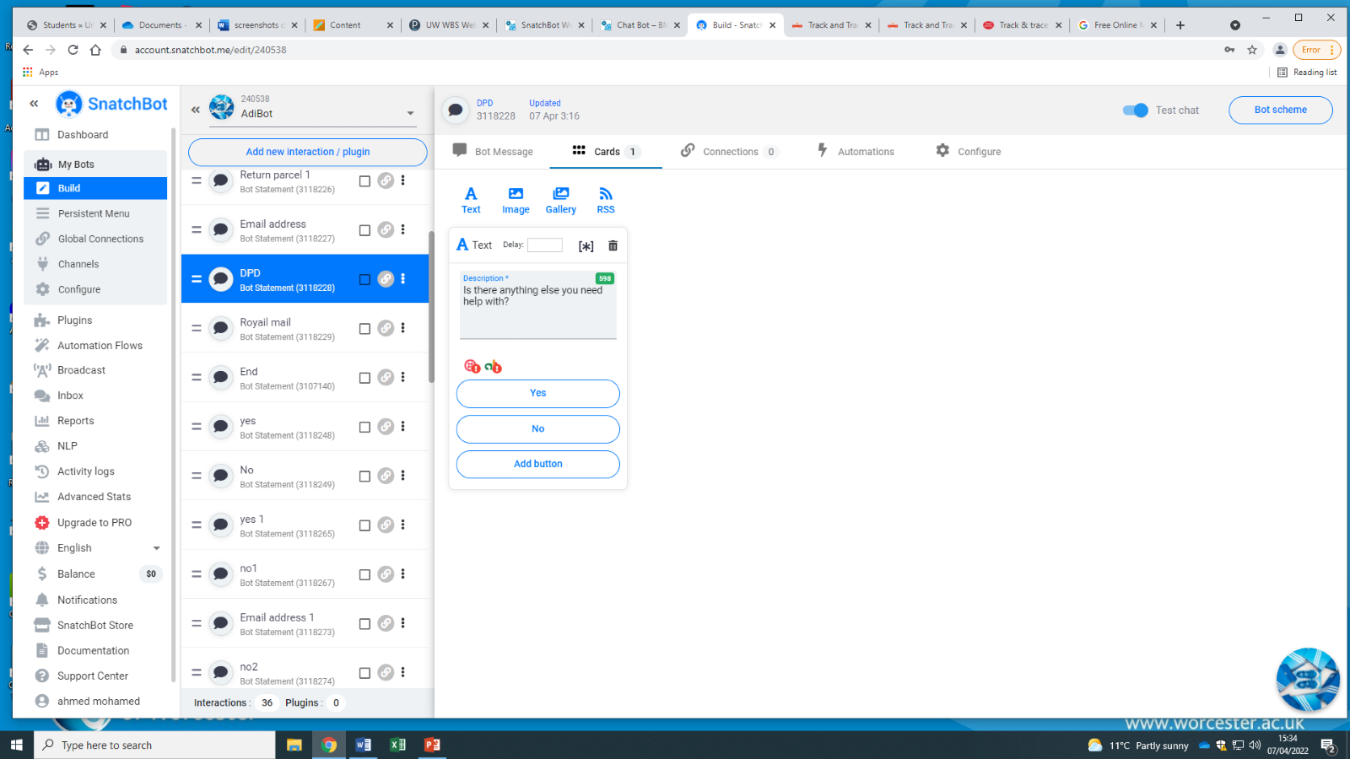
4 | Unit | Testing: returns and looking deeper into the interactions which provided a link.  Location: 3rd interaction of the return part of the snatchbot. | Input: press on ‘test interaction’  Criteria: you will have a choice of 2 options and one being a URL link that is provided just above the button interactions. | You press the button interaction with the link and that should allocate you to the website. | I was correctly taken to the website. | Pass | No actions were needed to act. | 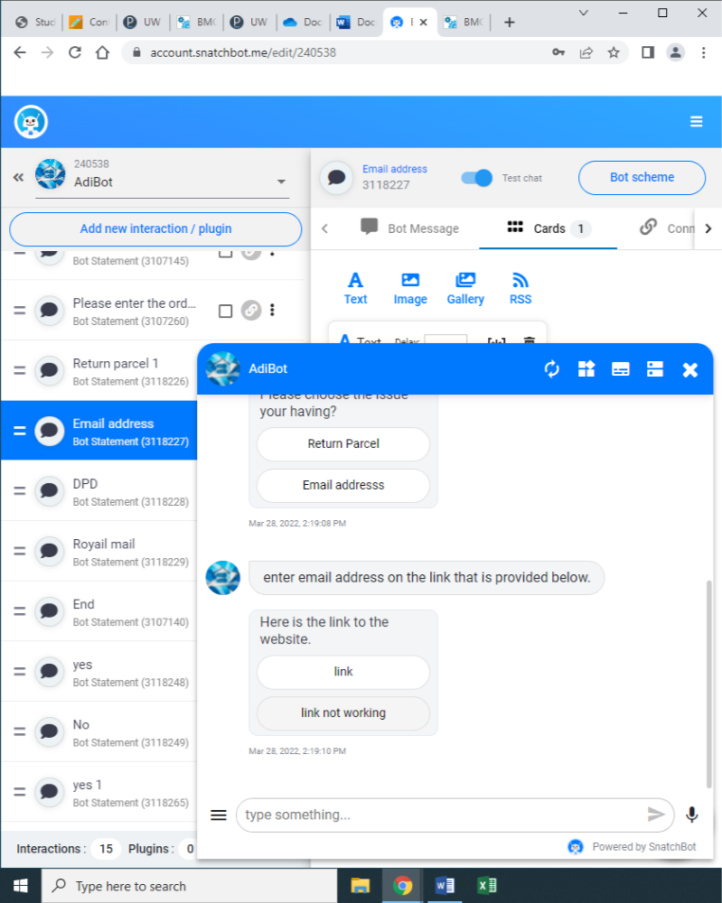
5 | Unit | Testing: returns and investigates the interactions that have a link which is a button interaction.  Location 4th interaction in the return part of the snatchbot. | Input: press on ‘test interaction’.  Criteria: you will have a choice of 2 options and one being a URL link that is provided in a button interaction. One click should take you straight to the page. | One click should take you straight to the page. | The result was successful. | Pass | No action needed to be taken. | 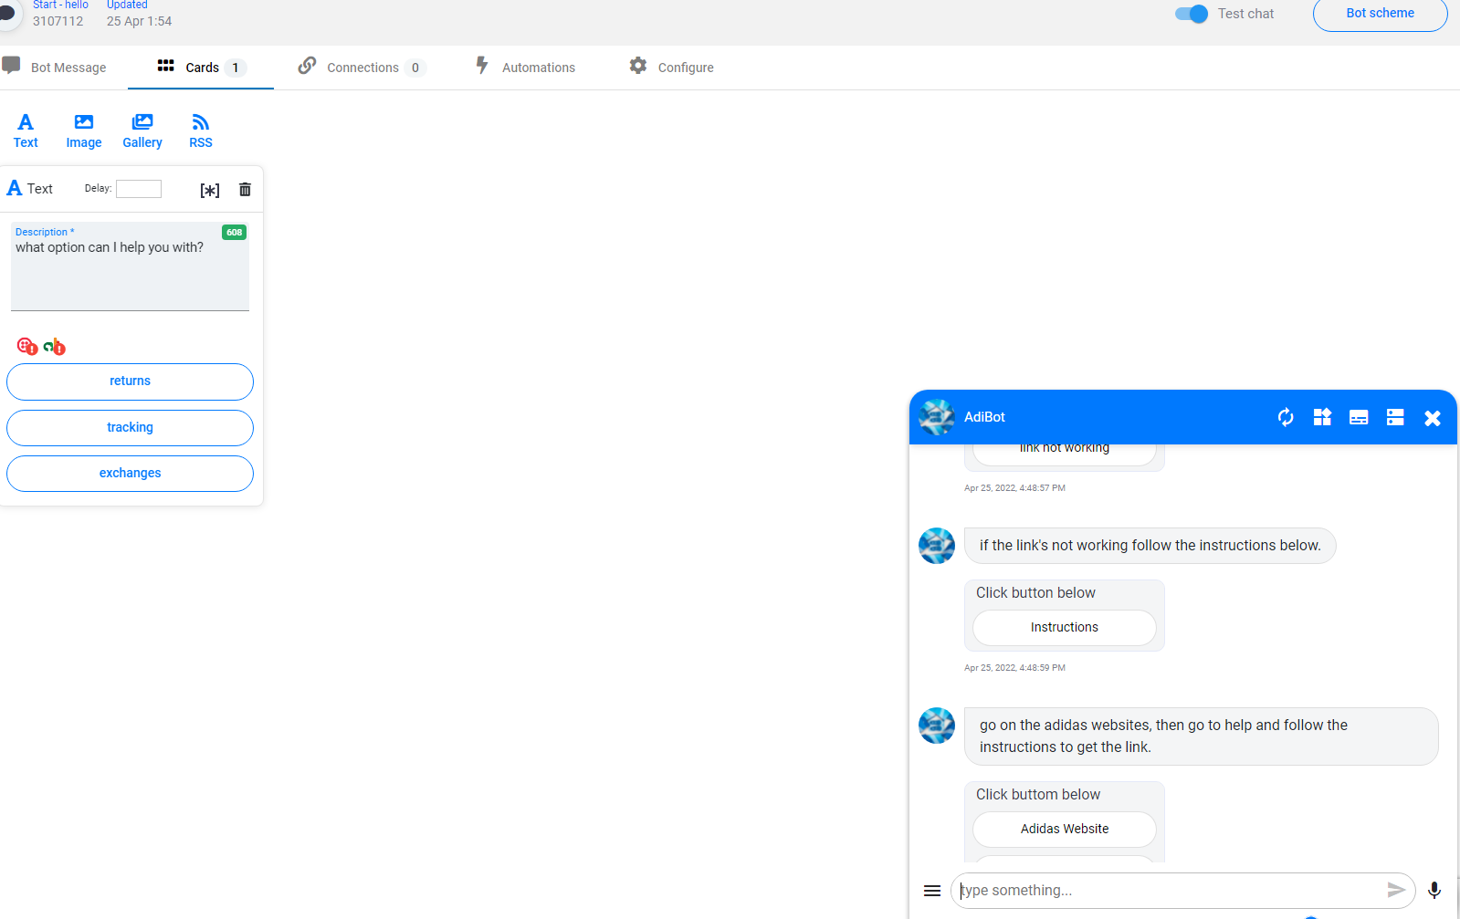
6 | Unit | Testing:  Testing the bot messages for returns  Location:  The strand I will be testing is the button messages and where it leads on to. | Input: type in your message and press enter.  Criteria: Based on this design it will simplify the button interactions for you and give you a heading explaining what to do. | One sentence and a press enter should do. | What happened is what I expected | Pass | No action needed to be taken. | 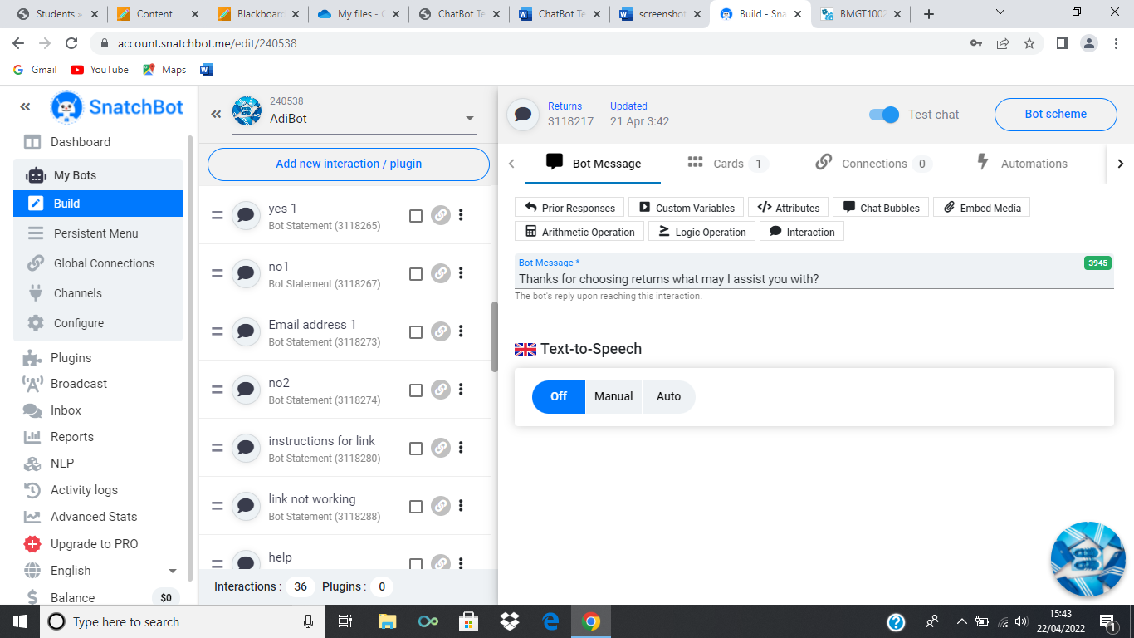
7 | Unit | Testing: returns interactions one of the final parts to round off.  Location: 5th interaction of the return part of the snatchbot. | Press on ‘test interaction’.  Criteria: you will press the button interaction that says ‘done’. | You are expected to go straight back up to the start where you can now talk about exchanges or refunds. | What happened is what I expected. | Pass | No action needed to be taken. | 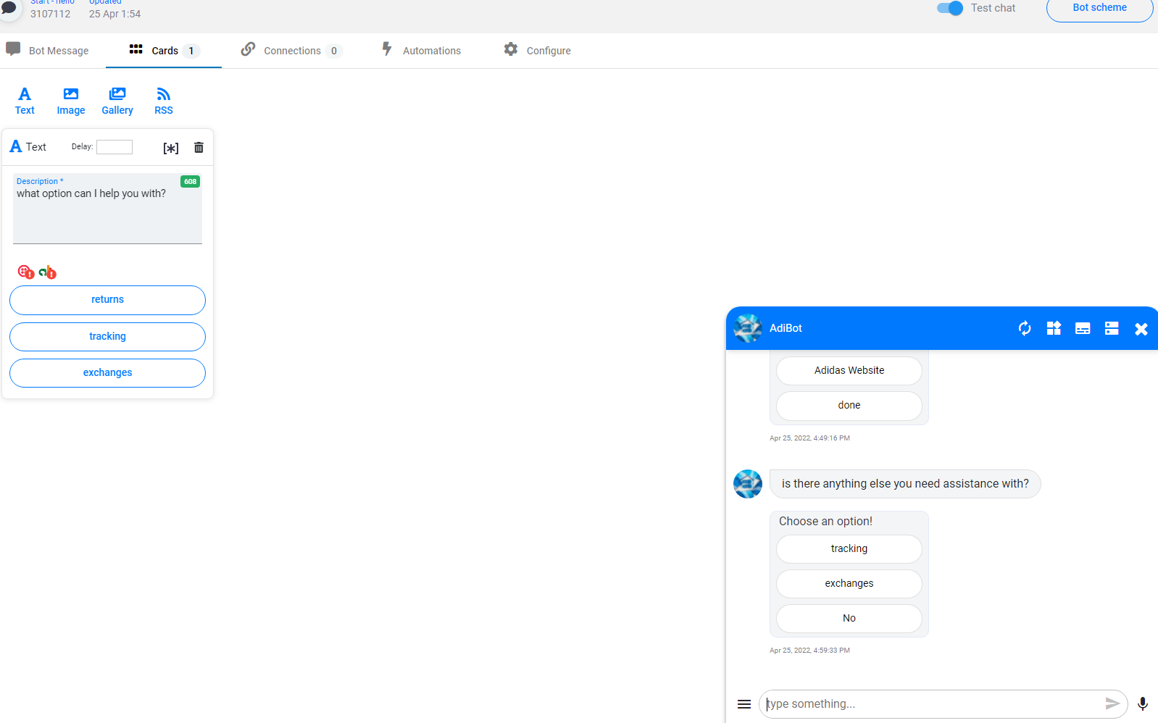
8 | unit | Testing: no interaction.  Location; first strand of chatbot.  Google chrome using a laptop and on snatchbot. | Input: click on ‘test interaction’.  Criteria: this should be the last thing to finalize your experience with the chatbot and it should give you one final message. | This message should be the only thing that appears on the connection. It should be visible. | What happened is what I predicted. | pass | No action needed to be taken. | 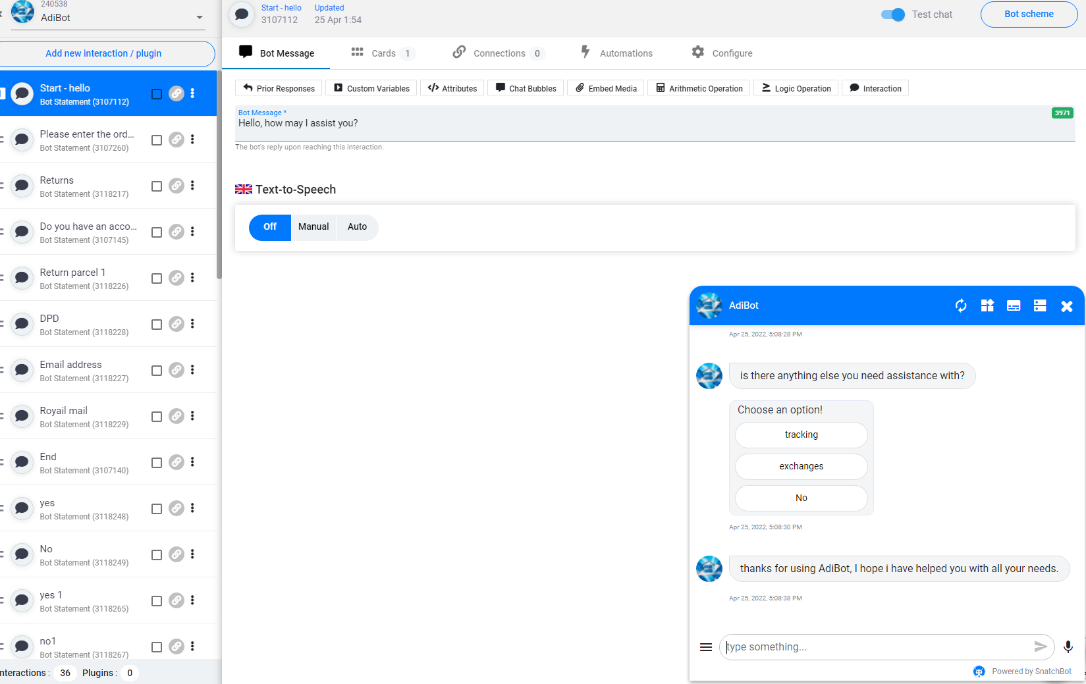
9 | unit | Testing: tracking interaction.  Location 2nd interaction on the tracking part of the snatchbot. | Press on test interaction.  Criteria: you will have 4 button interactions. To pick from on this one. Because you can only add 3 max buttons on each card. So, I had to add another card onto this interaction. | Creating a card and adding another button should allow it all to assemble. | What happened is what I expected. | Pass | No action needed to be taken. | 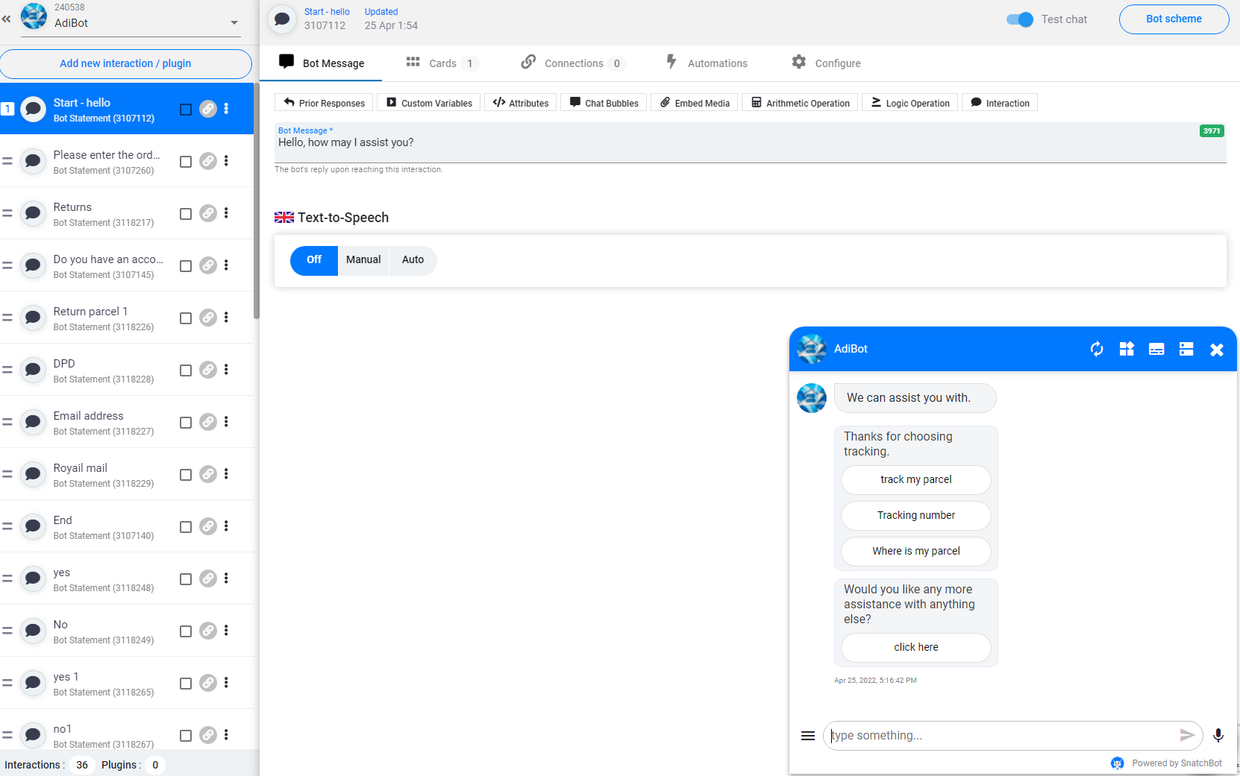
10 | Integration. | Testing: the connection between the hello interaction and the exchanges interaction.  Location: strand 1 of the chatbot. Using google chrome on laptop. | Input – press ‘exchange tab on the button displayed on the hello interaction.  Criteria: allocate to exchange tab when button is clicked. | Taken to exchanges interaction, this will display further options. | Taken to exchanges interaction after clicking on the tab. | pass |  | 